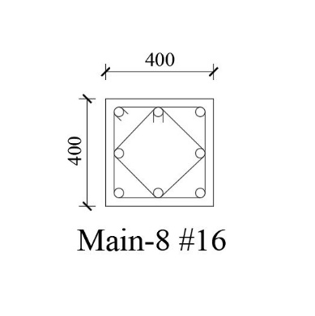 | 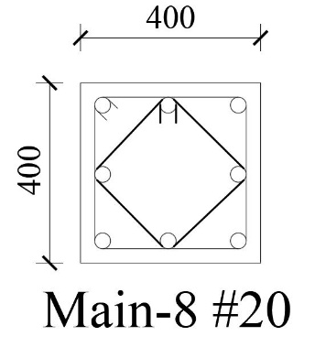 | 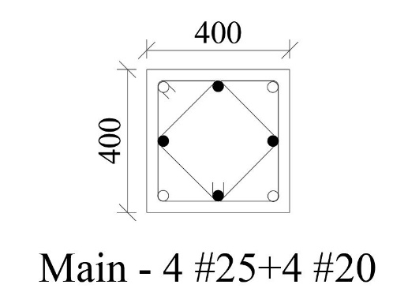 | 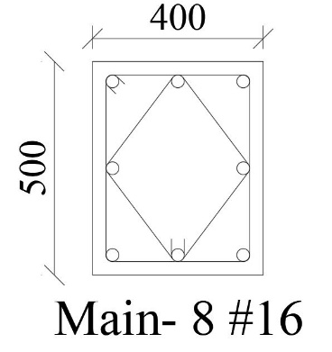 | 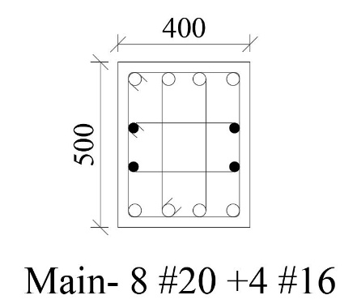
C1 | C2 | C3 | C4 | C5
C-4X4-1 | C-4X4-4 | C-4X4-7 | C-4X5-1 | C-4X5-7
T1 | T1 | T1 | T1 | T1
T2 | T2 | T2 | T2 | T2
H1 | H1 | H1 | H1 | H1
C6 | C7 | C8 | C9 | C10
C-4X5-10 | C-4X6-4 | C-4X6-7 | C-4X7-1 | C-4X7-7
T1 | T1 | T1 | T1 | T1
T2 | T2 | T2 | T2 | T2
H1 | H1 | H1 | H1 | H1

